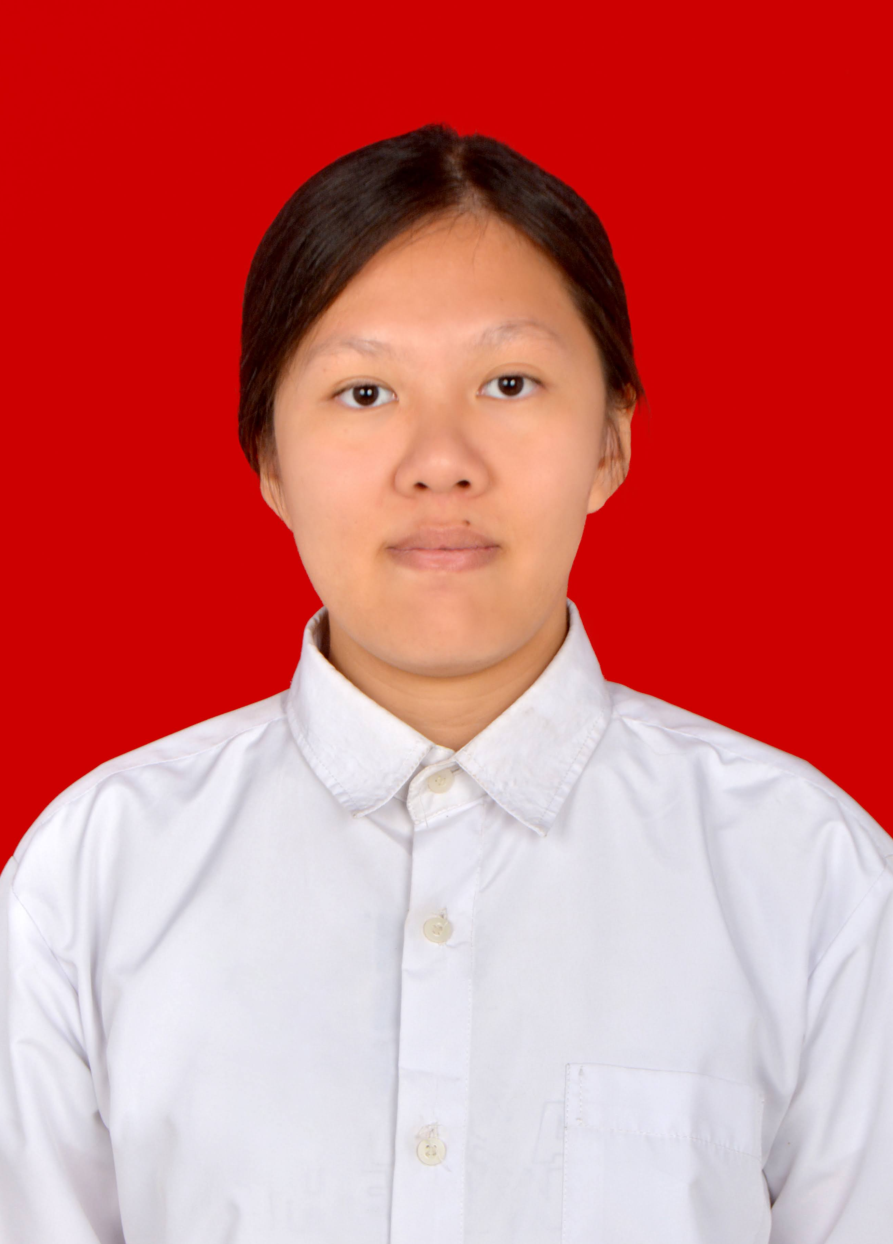
Posisi yang dilamar : Programmer (Front End Developer)________________
Position applied
- IDENTITAS DIRI
PERSONAL INFORMATION

1. Nama Lengkap : Yohanna Astrid Adhipurusa_________________________
Full Name
FOTO

2. Jenis Kelamin : Laki-Laki / Perempuan
Sex Male / Female

3. No KTP : 3216065209010007_________________________________
ID Number

4. Tempat / Tanggal lahir : Bekasi, 12 September 2001 __________________________
Place / Date of Birth

5. Alamat Sesuai KTP : JL. BIMA BUANA UTAMA NO.123 Kode Pos : 17510____________
KTP Address Post Code
6. Alamat Sesuai Domisili : JL. BIMA BUANA UTAMA NO.123 Kode Pos : 17510____________
Domicile Address Post Code

7. Telepon Rumah : __________________________ Telepon Seluler : 0852-8110-5082____
Home Telephone Cellphone

8. Status Perkawinan : Belum Kawin________________
Marital Status

9. Agama : Katolik_____________________
Religion

10. e-mail : astrid.adhipurusa@gmail.com_
e-mail

- KELUARGA

FAMILY

Nama *)  Name *) | Jenis Kelamin  Sex | Tempat, tanggal lahir  Location, date of birth | Pendidikan  Education | Pekerjaan  Occupation | Nama Perusahaan  Employer’s name
Ayah/Father  Eugenius Purusa Yulianto | Pria | Kebumen, 8-7-1965 | D4 | Pekerja Swasta | PT. BALI SMARTCARD SOLISINDO
Ibu/Mother  Irene Minah Lasimon | Wanita | Pontianak, 4-4-1967 | S1 | Guru | EDFUN Education
Saudara Kandung / Sibling (1)  Geraldus Hansen Adhipurusa | Pria | Jakarta, 13-11-1996 | S2 | Pekerja Swasta | PT. INTEGRA INDOCABINET TBK.
Saudara Kandung / Sibling (2)
___________________
Saudara Kandung / Sibling (3)
___________________
Suami-Istri/ Spouse
___________________
Anak / Children (1)
___________________
Anak / Children (2)
___________________
Anak / Children (3)
*) Mohon diberikan tanda (Alm.) di awal nama keluarga apabila sudah meninggal

- LATAR BELAKANG PENDIDIKAN
EDUCATIONAL BACKGROUND

Pendidikan Formal  Formal Education | Nama Institusi  Institution Name | Kota  City | Fakultas / Jurusan  Major / Faculty | IPK  GPA | Tahun Pendidikan  Year of education
 |  |  |  |  | Dari  from | Sampai  to
SD / Elementary School | IPEKA Grand Wisata | Bekasi | - |  | 2010 | 2015
SMP / Junior High School | IPEKA Grand Wisata | Bekasi | - |  | 2015 | 2017
SMU / Senior High School | IPEKA Grand Wisata | Bekasi | IPA |  | 2017 | 2019
Akademi (D3) / Sarjana (S1)  Academy / Undergraduate | National Dong Hwa University | Hualien, Taiwan | Computer Science and Information Engineering | 4.17/4.5 | 2019 | 2023
Pasca Sarjana (S2)
Graduate

Pendidikan non formal / kursus /training /seminar  Non formal education / course / training / seminar | Bulan / Tahun  Month / Year | Keterangan  Remarks
`
- KETERAMPILAN
SKILLS

Bahasa / Language | Tingkat Penguasaan (Skala 1-5) *)  Mastering Level (Scale 1-5) *) | Catatan / Remarks
Inggris | 5 | Fluent
Indonesia | 5 | Native

Komputer / Computer | Tingkat Penguasaan (Skala 1-5) *)  Mastering Level (Scale 1-5) *) |  | Catatan / Remarks
Javascript+HTML+CSS | 5
VueJS | 5
ReactJS | 3
*) 1=Poor; 2=Fair; 3=Good; 4=Very Good; 5=Excellent

Keterampilan lain yang relevan dengan pekerjaan  Other skills relevant to job |  | Tingkat Penguasaan (Skala 1-5) *)  Mastering Level (Scale 1-5) *) |  | Catatan / Remarks
Git |  | 4
TailwindCSS |  | 5
Figma |  | 4
*) 1=Poor; 2=Fair; 3=Good; 4=Very Good; 5=Excellent
- KONTAK DARURAT
EMERGENCY CONTACT

Nama  Name | Alamat  Address | Kota  City | Telepon  Telephone | Hubungan  Relation
Irene | JL. Bima Buana Utama no.123 | Bekasi | 0812-9592-6392 | Ibu
- RIWAYAT PEKERJAAN (mulai dari pekerjaan yang terakhir)
EMPLOYMENT HISTORY (starting from the recent job)

Dari-Sampai  From-To | Nama Perusahaan  Name of Company | Kota  City | Jabatan  Position |  | Atasan Langsung  Direct Supervisor | Gaji Pokok  Basic Salary | Alasan Keluar  Reason for Leaving
06/2020~  02/2023 | AI Lab of NDHU | Hualien, Taiwan | Front End Developer |  | Wayne Chen | Rp 3.000.000 | Mengerjakan tugas ahkir kuliah
Uraian tugas & tanggung-jawab di perusahaan sekarang / terakhir  Job description & responsibility in current / previous company |  |  |  | Struktur organisasi perusahaan sekarang / terakhir  Organisation structure in current / previous company
- Membuat front-end dari projek-projek yang di berikan
- Membuat laporan setiap minggu untuk mengulas progres pekerjaan dengan client
- Mendengarkan permintaan client dan mendiskusikan solusi
- Mengsuport rekan kerja dalam mempelajari git dan vue

- REFERENSI (Kepada siapa kami dapat menanyakan diri Anda lebih lengkap, selain saudara Anda)
REFERENCE (List of reference who know your academic or professional performance, not your family)

Sumber  Source | Nama  Name | Alamat & Telepon  Address & Phone | Keterangan  Remarks
1. Kolega / Collegue  2. HR Manager / Director  (Previous Company)  3. Atasan Langsung / Superior  (Previous Company) | 1. _____________________  2. _____________________  3. _____________________ | _______________________  _______________________  _______________________ | _______________  _______________  _______________

- KETERANGAN TAMBAHAN
Additional Information

Apakah Anda pernah melamar di perusahaan ini sebelumnya?  Kapan dan untuk posisi apa?  Have you ever applied to our company before?  When and for what position? | Tidak
Apakah Anda terikat dengan perusahaan lain saat ini?  Are you currently engaged in other company? | Tidak
Apakah Anda mempunyai teman / saudara yang bekerja di  perusahaan ini? Sebutkan nama dan hubungan Anda.  Do you have any family or friend working in this company?  Please mention his/her name and your relationship with him/her | -
Bila diterima, bersediakah Anda bertugas di luar kota?  Are you willing to be posted out of town? | Ya
Jenis pekerjaan apa yang Anda sukai?  What kind of job do you prefer? | - Kantor / Office  - Lapangan / Site
Bila diterima, berapa gaji dan fasilitas apa yang diharapkan?  What is your expected salary and benefits? | Rp 8.000.000 – Rp 12.000.000
Bila diterima, kapan Anda dapat mulai bekerja?  When will you be ready to join? | 11 September 2023
Menurut Anda apa kelebihan dan kekurangan pada diri Anda?  Sebutkan masing-masing 5 poin.  What are your strengths and weaknesses? Please mention 5 points each. | Kelebihan / Strengths  - Fast learner  - Strong analytical skill  - Good at teamwork  - Structured  - Responsible  Kekurangan / Weaknesses:  - Straight-forwardness  - Perfectionism  - Overcommitment  - Multi-tasking  - Assertiveness
Di dalam pengalaman hidup Anda, ceritakan tentang peristiwa yang:  - paling membahagiakan  - paling menyedihkan  Please explain what is the happiest and the saddest moment in your life. | Paling membahagiakan  The happiest moment  Opening up to my friends after a long time  Paling menyedihkan  The saddest moment  Keeping my thoughts to myself
Ceritakan kesuksesan di dalam bekerja yang pernah Anda alami.  Please explain your achievement in previous job.  Ceritakan kegagalan di dalam bekerja yang pernah Anda alami.  Please explain your failure in previous job. | Kesuksesan / Achievement  - Di dalam proyek / program apa?  In what project / program?  Bluetooth connected heartrate monitor.  - Apa peran Anda di dalam kesuksesan tersebut?  What was your role in the achievement?  Creating the app and testing it.  - Berapa jumlah anggota team Anda saat itu?  Please mention the number of your team.  For that specific project, 2.  - Jelaskan faktor apa saja yang diperlukan untuk dapat mencapai keberhasilan tersebut?  What were the most important factors in the achievement? Please explain.  Perceptiveness to creating new solutions.  - Hambatan apa saja yang dialami dalam mencapai keberhasilan?  What was the barrier to success?  Fatigue.  Kegagalan / Failure  - Di dalam proyek / program apa?  In what project/program?  Previous version of heartrate monitor project.  - Apa peran Anda di dalam kegagalan tersebut?  What was your role in the failure?  Not knowing that a solution doesn’t exist for it yet.  - Berapa jumlah anggota team Anda saat itu?  Please mention the number of your team.  2  - Apa saja yang menjadi faktor penyebab kegagalan tersebut dan bagaimana solusinya?  What were the most important factors in the failure and what were the solutions? Please explain.  At that time, we were using flutter. Flutter didn’t have good control for iOS’ Bluetooth. The solution was to code the app specifically for iOS instead of for both iOS and Android  - Bagaimana status proyek / program tersebut setelah mengalami kegagalan?  How was the project / program status after the failure?  Remade in XCode.
Ceritakan jenjang karir yang Anda harapkan.  Please explain your career expectation. | 5 tahun ke depan / Next 5 years :  Become a senior in my position and/or apply for a masters degree abroad  10 tahun ke depan / Next 10 years :  Have enough experience to design solutions as a leader and enough insight to generate my own passive income.
Menurut pendapat Anda, apa saja persyaratan yang harus dimiliki untuk menduduki posisi yang Anda lamar sekarang?  Please explain the qualifications for the job you apply. | Kepemimpinan (Leadership)  Empathy, communication skills  ____________________________________________  Teknis (Technical skill)  Good logic, web development knowledge  ____________________________________________  Sikap kerja (Attitude)  Openness, diligence  ____________________________________________
Ceritakan tentang gaya kepemimpinan Anda.  Please explain your leadership style. | Gaya kepemimpinan saya  My leadership style  The way I lead is with foresight and empathy. I assess my teammates and decide what each of them are able to take on, while also being ready to reassign work when needed. In addition, I encourage my team to support each other by being there for them as well as relying on them.
Menurut Anda, bagaimanakah gaya kepemimpinan atasan yang ideal itu? Jelaskan.  In your opinion, how is the ideal leadership style? | Kepemimpinan yang ideal  Ideal leadership  Your team is only as good as your weakest member, therefore, a good leader is one that takes care to not leave anyone behind. Being able to motivate and inspire your team members is, in my opinion, the key to becoming a great leader.
Secara singkat, siapakah Anda?  In short, who you are? | - Pengambil keputusan (Decision maker)  - Penyelesai / pemecah masalah / Problem solver  - Penganalisis masalah (Analyst)
Apakah Anda pernah terlibat dalam tindakan kriminal atau dijatuhi hukuman oleh pengadilan karena tindakan kriminal?  Have you been involved in any criminal activities or being sentenced by the court of law for any criminal case? | - Ya / Yes  - Tidak / No
Apakah Anda mengizinkan pihak Innilabs melakukan reference check ke perusahaan tempat Anda bekerja sebelumnya?  Do allow Innilabs to do reference check to your previous company? | - Ya / Yes  - Tidak / No

BACALAH PERNYATAAN INI DENGAN TELITI
PLEASE READ THIS STATEMENT CAREFULY

Saya menyatakan bahwa informasi yang saya berikan pada formulir ini benar, lengkap dan akurat. Saya mengerti jika terdapat pemalsuan atau pengurangan informasi dapat mengakibatkan pemutusan hubungan kerja. Saya memberi wewenang kepada perusahaan untuk menyelidiki tingkah laku, reputasi dan latar belakang pekerjaan, jika diperlukan.

I hereby affirm that the information given by me on this application for employment is true, complete and accurate. I understand that any falsification or omission will be considered sufficient cause for dismissal. I authorize a though investigation to be made in connection with this application concerning my character, general reputation, employment and educational background. Whichever may be applicable.

Bekasi ,28 Agustus 2023


(Pelamar/Applicant)
Yohanna Astrid Adhipurusa

